#### [Swag](http://timisoaractf.ro/challenge?id=24) (100pts)

This challenge featured a simple stack based buffer overflow since it used the gets() function to read input. Despite that, the flag was left in the binary, so it could be easily solved in another way.

Opening the file in IDA, we get this decompilation of the main function:

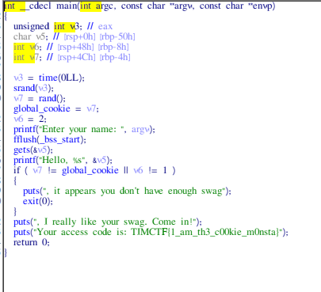

Which clearly shows the flag in plaintext